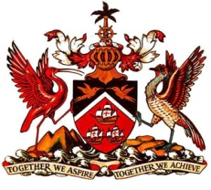

PERMANENT MISSION OF THE REPUBLIC OF TRINIDAD AND TOBAGO
TO THE OFFICE OF THE UNITED NATIONS, GENEVA

Statement at the Universal Periodic Review (UPR) of the Republic of Singapore, Palais des Nations, Geneva, 27th January 2016

Thank you Mr. President.

Trinidad and Tobago congratulates Singapore on its drive to foster an inclusive and more just society. In this regard, my delegation applauds amendments made to legislation to enhance the protection of workers, girls and young women; the improved access to social services; as well as initiatives to ensure the wellbeing of older Singaporeans. Sustained efforts to improve the system of education and promote lifelong learning are indeed also notable.

Trinidad and Tobago recognises that Singapore seeks not only to nurture its own human resources in its ongoing development thrust, but also shares its best practices and learning experience with the wider international community, for example, through its Cooperation Programme. Trinidad and Tobago has been the grateful beneficiary of such laudable knowledge-sharing by Singapore in the past and underscores the value and importance of the widespread adoption by others of such a policy in the context of implementation of Agenda 2030, in the interest of strengthening development, especially in those parts of the world where there is a persistent development deficit.

My delegation recommends that Singapore:
- strengthens its awareness-raising programmes to more effectively address gender disparities and discrimination against women; and
- review its policy with respect to the ratification of ILO Convention No.111.

Trinidad and Tobago extends its very best wishes to Singapore, a small island developing state, with an impressive record of democratic stability and economic progress, for a successful Universal Periodic Review.

I thank you Mr. President.

